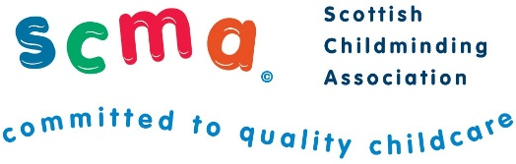

Scottish Childminding Association
CONFIDENTIAL

PART ONE
(This form will be used as contact information only and is not used within the selection and recruitment process)

NB: Curricula Vitae (CVs) will not be accepted as applications.
You must complete the application form in full.

First Name:

Surname:

Address:

Postcode:

Telephone Number:

Mobile Number:

Email Address:

Data Protection
SCMA is a data controller for the information you provide during the recruitment process unless otherwise stated. All of the information you provide during the process will only be used for the purpose of progressing your application, or to fulfil legal or regulatory requirements if necessary.

We will not share any of the information you provide during the recruitment process with any third parties for marketing purposes or store any of your information outside of the European Economic Area. The information you provide will be held securely by us and/or our data processors whether the information is in electronic or physical format.

We will use the contact details you provide to us to contact you to progress your application. We will use the other information you provide to assess your suitability for the role you have applied for.

If you have any queries about the process or how we handle your information, please contact us at the address or email address below:

Scottish Childminding Association, Argyll Court, Castle Business Park, Stirling, FK9 4TY
information@childminding.org


Scottish Childminding Association is a Company Limited by Guarantee, registered in Scotland.
Registered Charity No SC010489. Limited Company No 144696.

