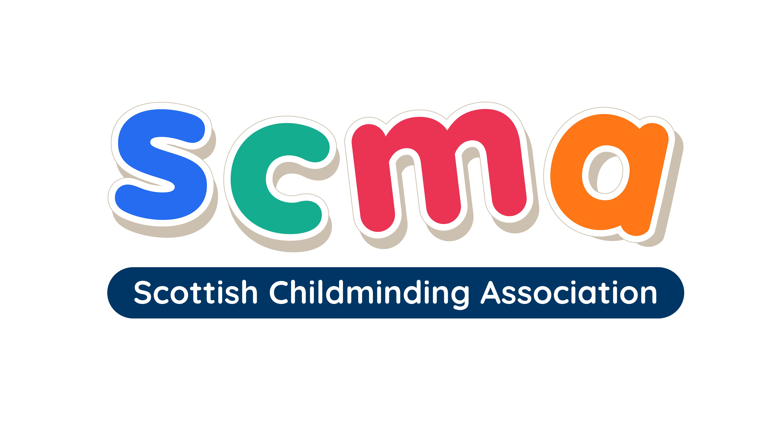

Scottish Childminding Association
CONFIDENTIAL

PART TWO

NB: Curricula Vitae (CVs) will not be accepted as applications.
You must complete the application form in full.

I am applying for the post of:

Where did you see the post advertised?

Your surname:

EDUCATION
Please give details of your relevant education, qualifications, and training, with the most recent at the top of the table. Original copies of qualifications are required at the interview stage.

School / College | Course(s) | Subject(s) Covered | Grade Achieved

EMPLOYMENT HISTORY (current or most recent job first)
Please give details of your relevant employment history, with your current or most recent job at the top of the table.

Dates:  To / From | Employer | Job | Reason for Leaving | Salary

RESPONSIBILITIES HELD
Please give details of the responsibilities you held during your current or previous employment that you feel would be beneficial to your application.

VOCATIONAL TRAINING
Please give details of vocational courses attended, including any professional qualifications etc.

INTERESTS AND LEISURE PURSUITS
Please give details of your interests and leisure pursuits, and include any voluntary work, if relevant.

REASON FOR APPLICATION
Please include skills and qualities you will bring to this job.

REFERENCES
Please give details of two referees:

1. Preferably current employer

NAME:

POSITION:

COMPANY:

ADDRESS:

TEL NO:

EMAIL:

(Please Note: We will only contact your current employer if you are offered the position)

2. Preferably a previous employer

NAME:

POSITION:

COMPANY:

ADDRESS:

TEL NO:

EMAIL:

CURRENT NOTICE PERIOD:

DATE YOU COULD START:

EQUAL OPPORTUNITIES POLICY
The Scottish Childminding Association (SCMA) is committed to an Equal Opportunities Policy in employment and will assess applicants for jobs without regard to disability, gender, language, race and religion.

If successful, applicants will be required to produce one of the following documents to evidence their eligibility to work in the United Kingdom:

- A document giving your National Insurance Number e.g., a P45 or letter from government agency or previous employer.
- A document showing that you can stay indefinitely in the UK or that you have no restriction preventing you from taking employment.
- A work permit or other approval to take employment from the Department of Education and Employment.
- A document showing you are a UK Citizen or have the right of abode in the UK. This may be a passport, an endorsement in a passport, a birth certificate.
- A document showing you are a national of a European Economic Area County. This may be a passport or national identity card.

DECLARATION
To the best of my knowledge and belief, the particulars given on this form are correct and complete.

Signed:

Date:

PLEASE RETURN TO: recruitment@childminding.org

OR

Recruitment
Scottish Childminding Association
Argyll Court, Castle Business Park
Stirling FK9 4TY

Please see covering email for closing date and receipt of completed applications.

Data Protection
SCMA is a data controller for the information you provide during the recruitment process unless otherwise stated. All of the information you provide during the process will only be used for the purpose of progressing your application, or to fulfil legal or regulatory requirements if necessary.

We will not share any of the information you provide during the recruitment process with any third parties for marketing purposes or store any of your information outside of the European Economic Area. The information you provide will be held securely by us and/or our data processors whether the information is in electronic or physical format.

We will use the contact details you provide to us to contact you to progress your application. We will use the other information you provide to assess your suitability for the role you have applied for.

If you have any queries about the process or how we handle your information, please contact us at the address or email address below:

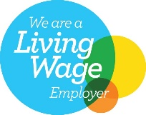
Scottish Childminding Association, Argyll Court, Castle Business Park, Stirling, FK9 4TY information@childminding.org

Scottish Childminding Association is a Company Limited by Guarantee, registered in Scotland.
Registered Charity No SC010489. Limited Company No 144696.

