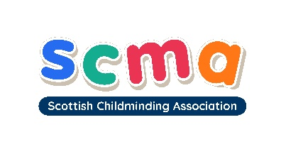

Scottish Childminding Association
CONFIDENTIAL

EQUAL OPPORTUNITIES MONITORING FORM: PART THREE

The following information will be used only for monitoring our Equal Opportunities Policy and will not be used for any other purpose. It will be separated from the application form before shortlisting.

Title: Mr ☐ Mrs ☐ Ms ☐ Other ☐

Please state title if other:

Surname: First Name:

Gender: Male: ☐ Female: ☐ Prefer not to say: ☐

Date of Birth:

Please describe your ethnic origin by ticking one of the boxes below:
White ☐
(Scottish, English, Northern Irish, Welsh, other white)
Black ☐
(African, Caribbean, British, other black)

Mixed ☐
(White/Black African, White/Black Caribbean, White Asian, other mixed)

Asian ☐
(Chinese, Indian, Pakistani, Bangladeshi, other Asian)

Any other Ethnic Group (please describe):

Prefer not to say: ☐

Do you consider yourself to have a disability? Yes ☐ No ☐

Do you require a work permit? Yes ☐ No ☐

Continued on next page…

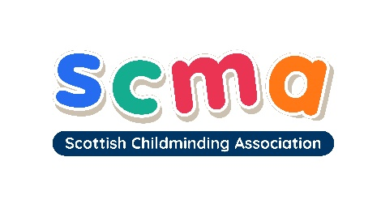

EQUAL OPPORTUNITIES MONITORING FORM

POLICY IMPLEMENTATION

Scottish Childminding Association would like to use your data to ensure that our Equal Opportunities Policy is fully and fairly implemented.

We will use your data to compile statistics on the representation amongst our workforce of the categories listed. To use this information, we need your consent. Signing in the space below will indicate that you consent to your data being used for the purposes stated. You may withdraw your consent at any time by contacting:

Sarah Sharp, Scottish Childminding Association, Argyll Court, Castle Business Park, Stirling, FK9 4TY or email recruitment@childminding.org

The aim of our policy is to ensure that no job applicant or employee receives less favourable treatment because of age, disability, gender reassignment, marriage and civil partnership, pregnancy or maternity, race, religion or belief, sex or sexual orientation.

Our recruitment selection criteria and procedures (including the areas or media sources which are used in the recruitment process) are frequently reviewed to ensure that individuals are selected, promoted and treated on the basis of their relevant merits and abilities and that no applicant or employee is disadvantaged by provisions, criteria or practices which cannot be shown to be justified.

Signed:

Date:

Data Protection
SCMA is a data controller for the information you provide during the recruitment process unless otherwise stated. All of the information you provide during the process will only be used for the purpose of progressing your application, or to fulfil legal or regulatory requirements if necessary.

We will not share any of the information you provide during the recruitment process with any third parties for marketing purposes or store any of your information outside of the European Economic Area. The information you provide will be held securely by us and/or our data processors whether the information is in electronic or physical format.

We will use the contact details you provide to us to contact you to progress your application. We will use the other information you provide to assess your suitability for the role you have applied for.

If you have any queries about the process or how we handle your information, please contact us at the address or email address below:
Scottish Childminding Association, Argyll Court, Castle Business Park, Stirling, FK9 4TY
information@childminding.org


Scottish Childminding Association is a Company Limited by Guarantee, registered in Scotland.
Registered Charity No SC010489. Limited Company No 144696.

