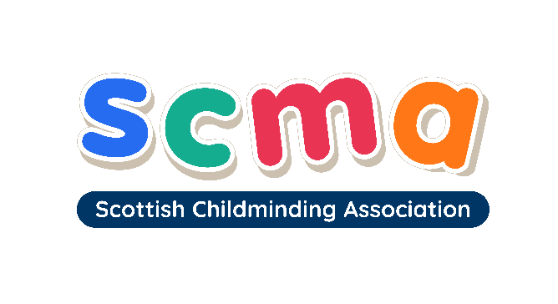

Scottish Childminding Association

Elected Member Nomination/Profile Form

Please complete the following form with your information, which will help the selection process to ensure that the Scottish Executive Board shall be representative of a Scotland-wide Board.

The Scottish Executive Board shall consist of a Convener, Treasurer and 15 ordinary members, with a maximum of three from any one local authority area.
Name of PROPOSER:

SCMA Membership Number:

Name of SECONDER:

SCMA Membership Number:
Name:

Address (including postcode):

Telephone No:

Email:

Local Authority:

SCMA Membership Number:

Please mark an X next to the role most appropriate to you:

- Childminder
- Community Childminder/Daycarer
- Partner Provider (Early Learning and Childcare)
Any other relevant information? (Please specify)
Date registered as a childminder:
Please detail any relevant training or qualifications:

Please provide a brief summary of your experience as a childminder:
(maximum of 50 words)

Please provide a summary of the reason why you decided to become an Elected Member: (maximum of 50 words)

Please return your completed form to:
louise.buchanan@childminding.org

Louise Buchanan, Scottish Childminding Association,
Argyll Court, Castle Business Park, Stirling, FK9 4TY
Tel: 01786 434956

